DAY 5 AGENDA

[Sprites creativity]

Go to <http://www.piskelapp.com/> and click on **Create a Sprite**

Export your result as an animated gif.

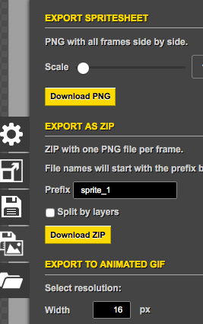

Change extension in your downloads folder from .gif to **.png**. Copy over png texture file, etc into Eclipse in an appropriate area. *MAKE SURE YOU SAVE APPROPRIATE SIZE (i.e., 16x16)

Alternatives:

Grab some animated gif and convert it to png:

Use: <http://www.irfanview.com>

-Accompanying software choice [Paint.net](http://filehippo.com/download_paint.net/) for downsizing gif if necessary.

[Video- great vid on making cursom animated item frames,etc. – VERY COOL!!!

check it: <https://www.youtube.com/watch?v=eFj76TMtbAg>

-*Reverse engineer minecraft jar file (location: **.minecraft/versions**) for all textures, etc.

and make sprites from existing files, etc.

[http://gaming.stackexchange.com/questions/204627/how-can-i-get-a-hold-of-minecrafts- default-textures](http://gaming.stackexchange.com/questions/204627/how-can-i-get-a-hold-of-minecrafts-%20%20%20%20%20%20%20%20%20%20%20%20%20%20%20%20%20%20%20%20%20%20default-textures)

Use some zip compression utility to open your jar ( 7zip, unrar, etc- check this link out also: <http://www.javadecompilers.com> )

[Sounds]

Playing sounds, etc. - -> p. 410

<http://minecraft.gamepedia.com/Sounds.json#File_structure>

<http://minecraft.gamepedia.com/NBT_format>

[Text Exercises (your choices!)]

All Resources (all source files & assets for all hours, including the Appendix & text pdf

link) are available as a zip file under **Resources** folder on git hub

-Recommended

Hour 15 [MCEdit](http://www.mcedit.net/downloads.html) …Alternative -- > [WorldEdit](http://dev.bukkit.org/bukkit-plugins/worldedit/)

Hour 16 Schematic Converter

*Hour 18 Using Techne to create models/textures

[Video – How to install Techne]

<https://www.youtube.com/watch?v=241amEbQbOk>

[Jar file creation, importation into MC]

-Grab your jar file (ex. In *Eclipse* under **build\libs\modid-1.0.jar** file)

-Place your jar file in **minecraft\mods** folder. In windows explorer search for

**%AppData%** then open up .minecraft\mods folder.

[[Saving MC data files](http://www.howtogeek.com/60264/how-to-backup-restore-and-sync-your-minecraft-saves-on-all-your-pcs/) –to flash drive, etc.]

In Windows Explorer navigate to : cd “**C:\Users\username\AppData\Roaming\.minecraft**” and search for the **saves** folder and find your World to copy over to your flash drive. Alternatively (more assured method?) – go to this link:

<http://minecraft.gamepedia.com/Tutorials/Playing_and_saving_Minecraft_on_a_thumb_drive>

[**Setting up modded server**]

Work in teams to mod some open sourced mod you can find over the web. Try to grab a

1.8.9 mod that is open sourced. Each team member can add some separate code in to work additional modding features to an existing mod your team has downloaded. Edit your mods in Eclipse. When complete update each mod to a git account including a jar file to be loaded in a designated server.

Good luck and as always happy modding!!!